Sarah’s Quiz Results
Module 5

Mini Quiz 1: Analyzing Patterns & Functions

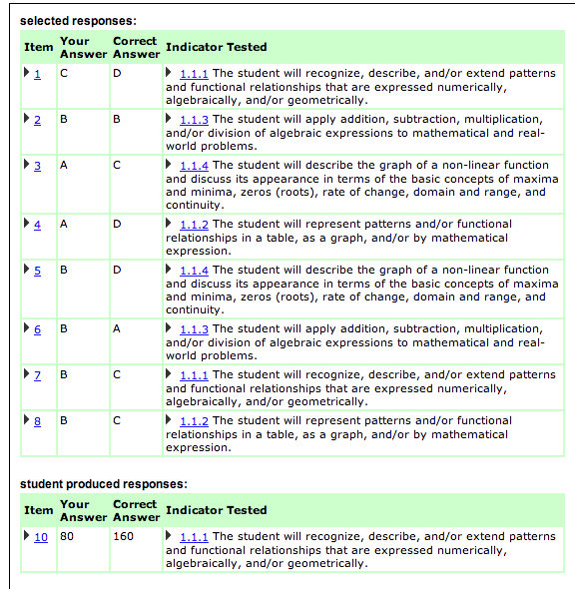

For this quiz, I missed problems 1, 3, 4, 5, 6, 7, and 8.
Here are my explanations for why I missed these problems:
(Detailed explanations go here!)

Do this with the 3 other category quizzes….

The other site:

The first “Topic” I chose was Analyzing Graphs. I chose this topic because this was an area I felt like I wanted more practice in. Here are my results:
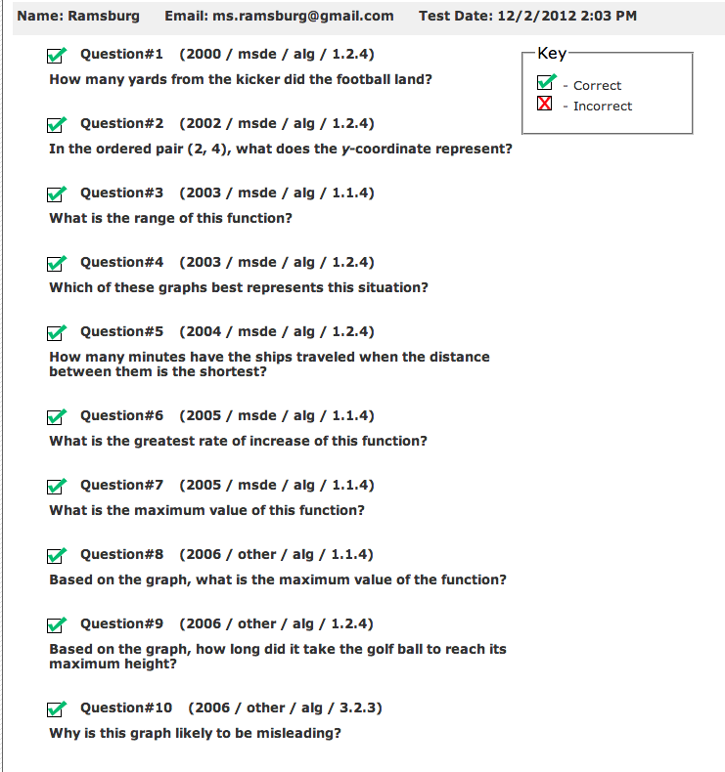
I got them all correct!

